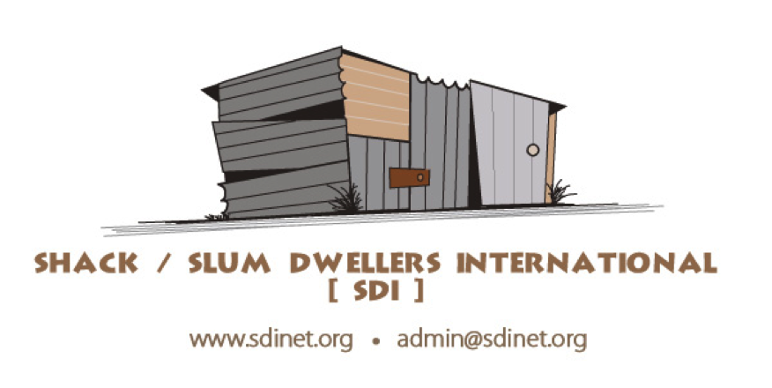

**COUNTRY INDICATORS**

**Date:**

**Country:**

**Reporting Period:**

**\*\* PLEASE REPORT TOTAL AMOUNTS TO DATE\*\***

|  |  |  |  |
| --- | --- | --- | --- |
| **MEMBERS, SAVINGS, AND LIVELIHOODS** | | | |
| Cities | 4 | Daily savings (USD) | 9163$ |
| Settlements | 2 | Loans from daily savings (USD) | 8289 |
| No. of savers | 1080 | Daily savings repayment (USD) | 7875 |
| No. of savings groups | 31 | UPF savings (USD) |  |
| No. of young people (under 24) in savings groups | 50 | Loans from UPF (USD) |  |
| No. of youth groups |  | UPF repayments (USD) |  |
|  |  | Other savings (USD) |  |
| **CITYWIDE FUNDS** | | | |
| No. of citywide funds | 1 | Govt. contribution to citywide funds (USD) | 0 |
| Savings in citywide funds (USD) | 0 | Other contributions to citywide funds (USD) | 33370$ |
| Loans from citywide funds (USD) | 14750$ | Repayments to citywide funds (USD) | 270$ |
|  |  | No. of projects funded (partially or fully) by citywide funds | 24 loans for 11 groups in 1 project |
| **LAND & LAND TENURE** | | | |
| Households with informal security of tenure |  | Households with customary systems of tenure | 5946 |
| Households with statutory tenure (individual) | 21 | Land secured (acres) |  |
| Households with statutory tenure (communal) |  | Cost (USD) |  |
| **INCREMENTAL UPGRADING** | | | |
| No. of settlements re-blocked/spatially reconfigured |  | No. of households affected |  |
| **BASIC SERVICES - Sanitation** | | | |
| No. of toilet blocks |  | Cost of toilet blocks (USD) |  |
| No. of seats in toilet blocks |  |
| No. of households serviced by toilet blocks |  |
| No. of shared toilets |  | Cost shared toilets (USD) |  |
| No. of households serviced by shared toilets |  |
| No. of individual toilets | 7 | Cost individual toilets (USD) | 286$ /unit = 2002$ |
| No. of households serviced by individual toilets | 7 |
| **BASIC SERVICES - Water** | | | |
| No. of individual taps |  | Cost of individual taps (USD) |  |
| No. of households with individual taps |  |
| No. of communal taps |  | Cost of communal taps (USD) |  |
| No. of households serviced by communal taps |  |
| No. of shared taps |  | Cost of shared taps (USD) |  |
| No. of households serviced with shared taps |  |
| No. of boreholes |  | Cost of boreholes (USD) |  |
| No. of households serviced by boreholes |  |
| **BASIC SERVICES - Drainage** | | | |
| No. of settlements with storm/waste water systems installed | 1 | Cost of storm/waste water systems (USD) | 534$ (between 170$ and 350$ / unit) |
| No. of households benefitting | 2 |  |
| **BASIC SERVICES - Energy** | | | |
| No. of solar distribution centers |  | Cost of distribution centers (USD) |  |
| No. of households with solar panels |  | Cost of solar panels (USD) |  |
| No. of communities trained in energy management |  |  |  |
| No. of employment opportunities created through solar projects |  |  |  |
| No. of households linked to city grid |  |  |  |
| **BASIC SERVICES - Waste Management** | | | |
| No. of households linked to community waste management systems |  |  |  |
| No. of households linked to government waste management systems |  |  |  |
| **PUBLIC AMENITIES** | | | |
| Community Centers |  | Cost (USD) |  |
| Creches/Schools |  | Cost (USD) |  |
| Clinics |  | Cost (USD) |  |
| Commercial Centers |  | Cost (USD) |  |
| Markets upgraded |  | Cost (USD) |  |
| Roads/pathways upgraded |  | Cost (USD) |  |
| Others (describe) |  | Cost (USD) |  |
| **HOUSING** | | | |
| Informal dwellings improved |  | Cost (USD) |  |
| Permanent houses under construction | 12 | Cost (USD) | 11369$ |
| Permanent houses completed | 4 | Cost (USD) | 3476$ |
| **INFORMATION COLLECTED** | | | |
| No. of cities profiled | 1 | No. of settlements mapped | 3 |
| No. of settlements profiled | 3 | No. of GIS maps | 3 |
| No. of settlements enumerated | 3 |  |  |
| **POLITICAL ENGAGEMENT** | | | |
| Agreements with National Govt. |  | Agreements with Universities |  |
| Agreements with Prov. Govt. |  | No. of city forums |  |
| Agreements with Local Govt. |  | No. of city forum meetings held |  |
| Impact on policy changes |  | | |